**TWO STAGE PIPELINE**

**EXP NO: 37**

**AIM:**To write a C program to implement two stage pipelining.

**PROCEDURE:**

Step1:Start

Step 2: Initialize the counter variable to 1.

Step 3:.Prompt the user to enter the first number (a).

Step 4:.Read the first number (a) from the user.

Step 5:Increment the counter by 1.

Step 6:Prompt the user to enter the second number (b).

Step 7:Read the second number (b) from the user.

Step 8:.Increment the counter by 1.

Step 9:Display the menu of operations: Addition, Subtraction, Multiplication, and Division.

Step 10:Prompt the user to select an operation (choice).

Step 11:Read the choice from the user.

Step 12:Use a switch statement to perform the operation based on the selected choice:

12.1For choice 1: Perform addition (res = a + b). Increment the counter by 1.

12.2For choice 2: Perform subtraction (res = a - b). Increment the counter by 1.

12.3. For choice 3: Perform multiplication (res = a * b). Increment the counter by 1.

12.4 For choice 4: Perform division (res = a / b). Increment the counter by 1.

12.5. For any other choice: Display "Wrong input".

Step 13: Display the value of the counter (the number of cycles taken).

Step 14:Prompt the user to enter the number of instructions (ins).

Step 15:Read the number of instructions (ins) from the user.

Step 16:Calculate the performance measure by dividing the number of instructions (ins) by the counter and store it in the performance measure variable.

Step 17:Display the performance measure Step 18:End

**PROGRAM:**

**#**include<stdio.h>

int

main()

{

int counter =1,a,b,choice,res,ins; printf("Enter number 1:"); scanf("%d",&a); counter = counter+1; printf("Enter number 2:"); scanf("%d",&b); counter = counter +1;

printf("1-Addition:\n2-Subtraction:\n3-Multiplication:\n4-Division:"); scanf("%d",&choice);

switch(choice)

{ case 1:

printf("Performing addition\n");

res = a+b; counter = counter+1; break; case 2:

printf("Performing subtraction\n");

res = a-b; counter = counter+1;

break; case 3:

printf("Performing Multiplication\n");

res = a*b; counter = counter+1; break; case 4: printf("Performing Division\n"); res = a/b; counter = counter+1;

break; default: printf("Wrong input");

break;

}

printf("The cycle value is:%d\n",counter);

printf("Enter the number of instructions:");

scanf("%d",&ins);

int performance_measure = ins/counter;

printf("The performance measure

is:%d\n",performance_measure);

return 0;

}

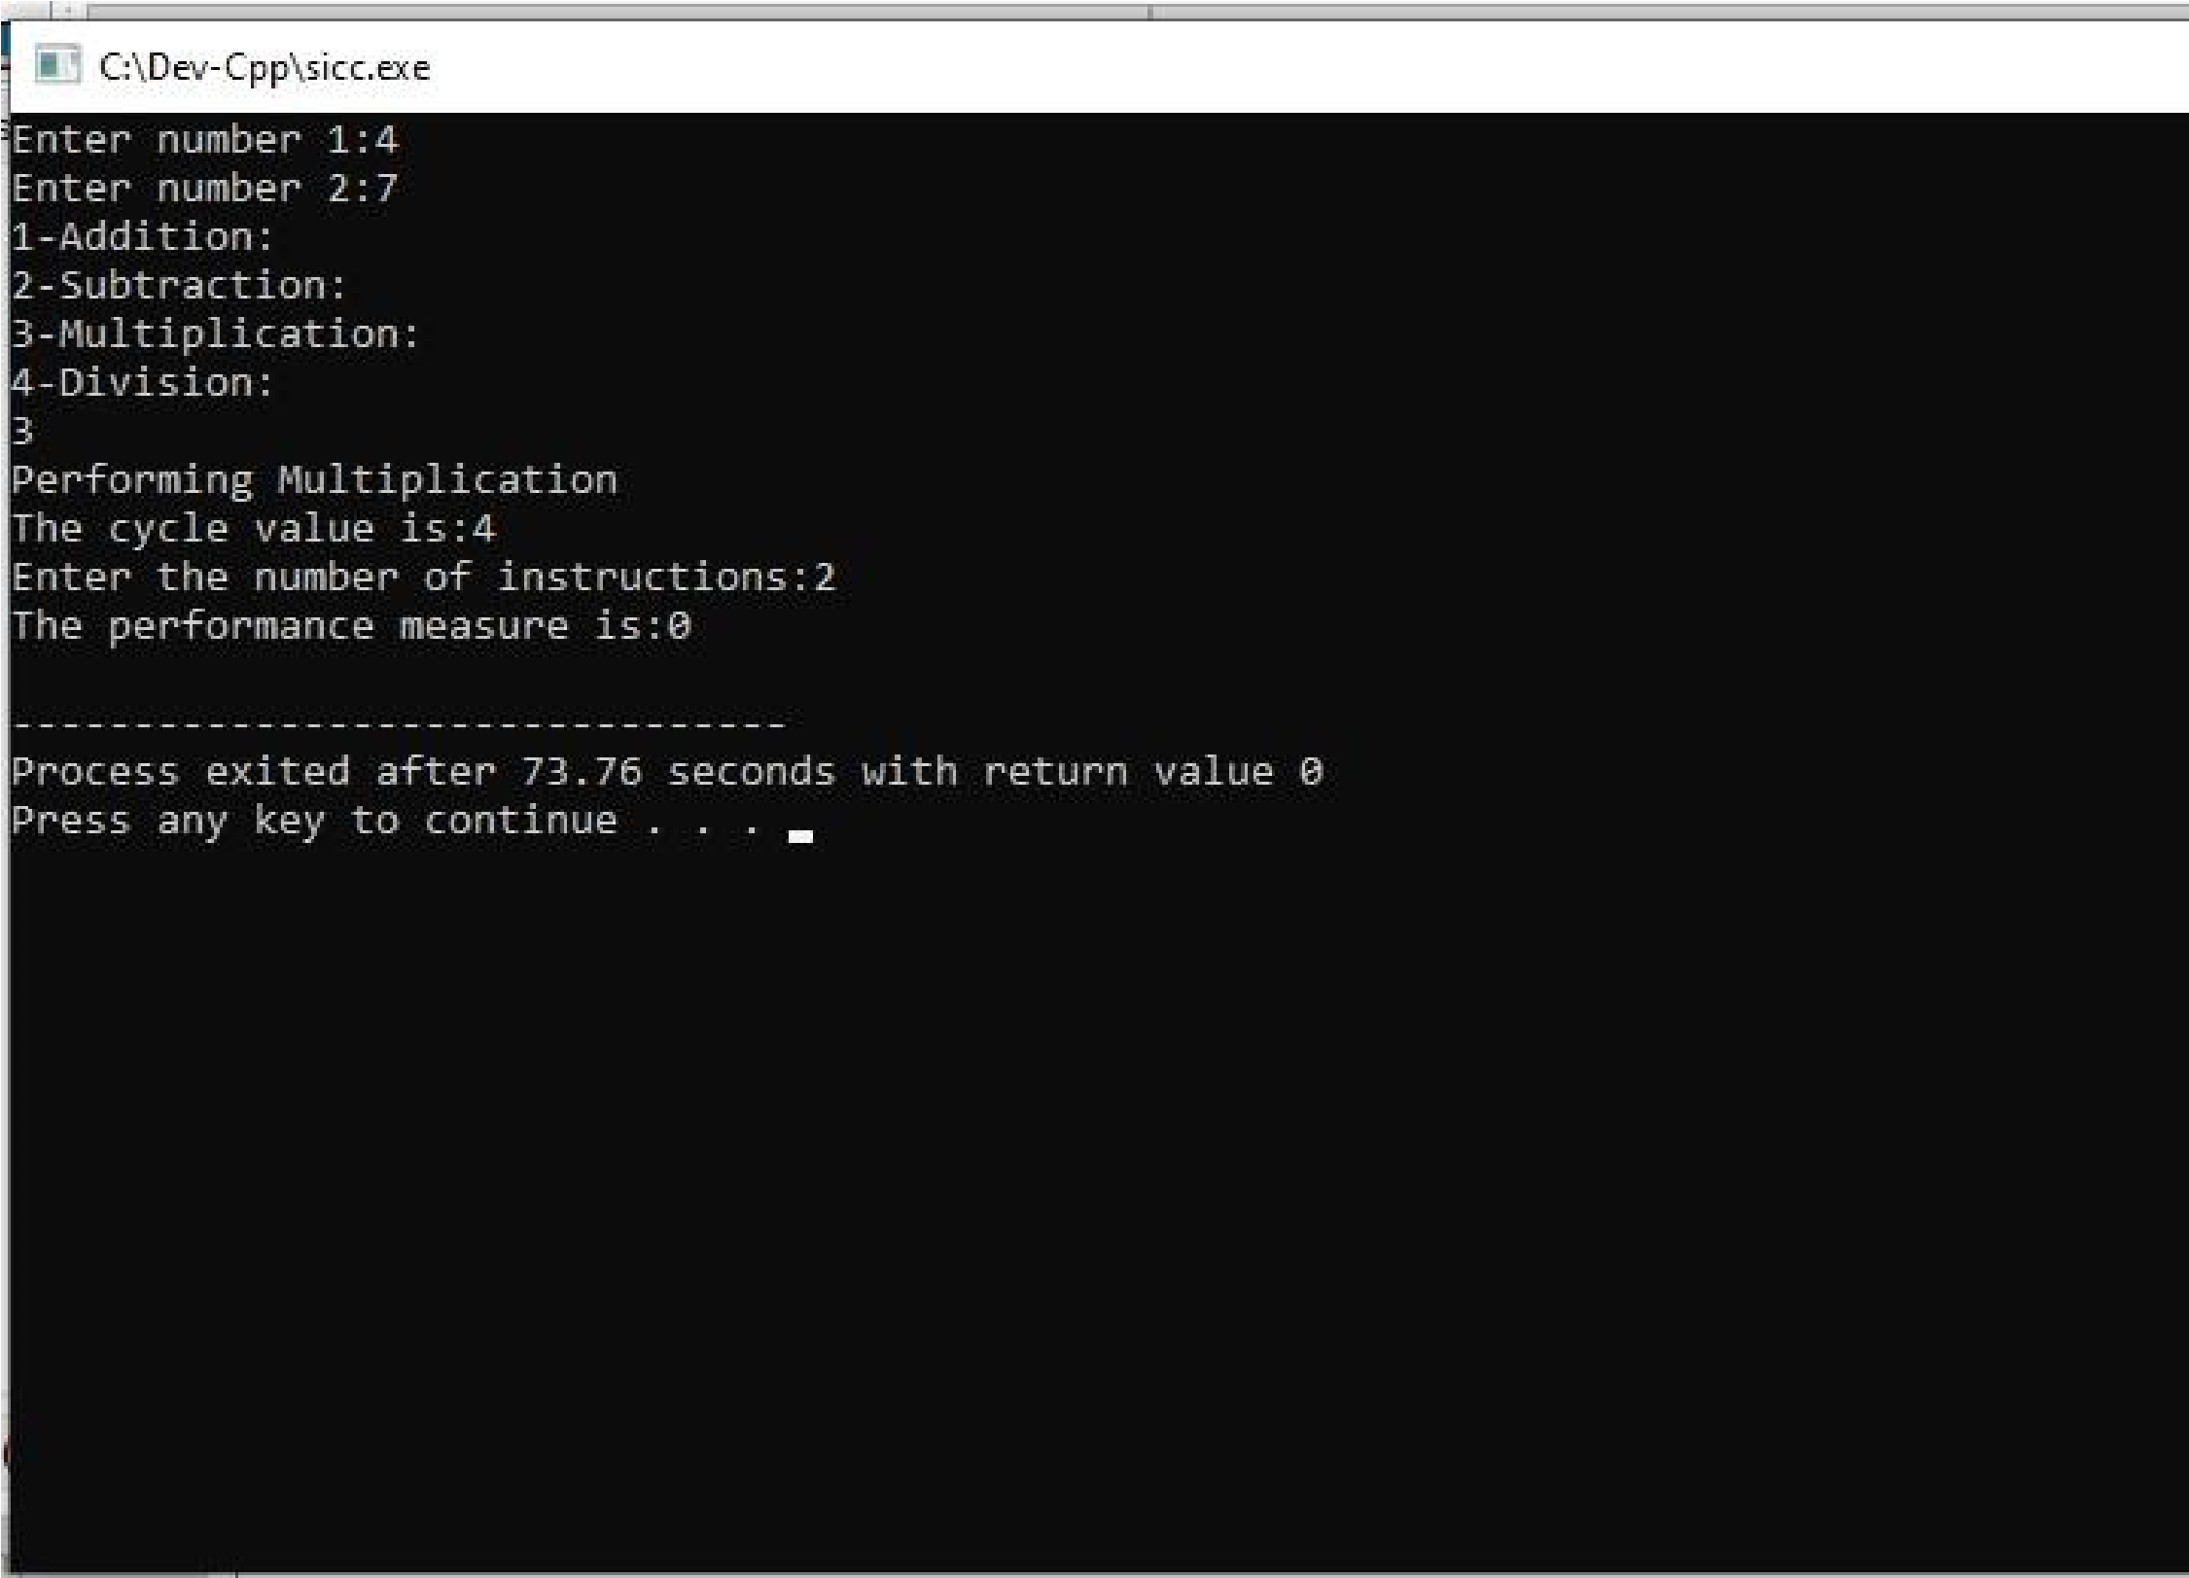

**INPUT & OUTPUT:**

**RESULT:** Thus the program was executed successfully using DevC++.